OneDrive Instructions:

**To upload a Syllabus:**

1. Using Google Chrome, go to Office.com
2. Make sure you are logged in with your SLPS email information
3. Click on the OneDrive App

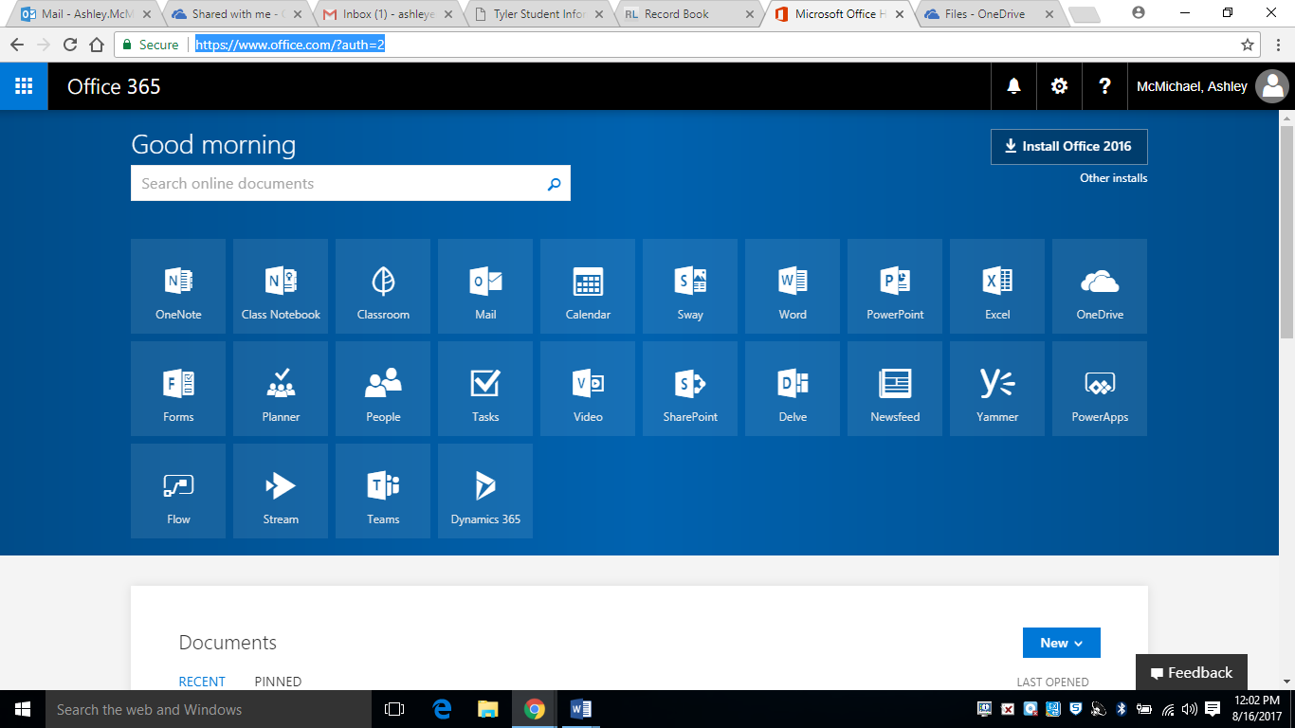

1. Click on “Shared with Me” on the left hand side of your screen

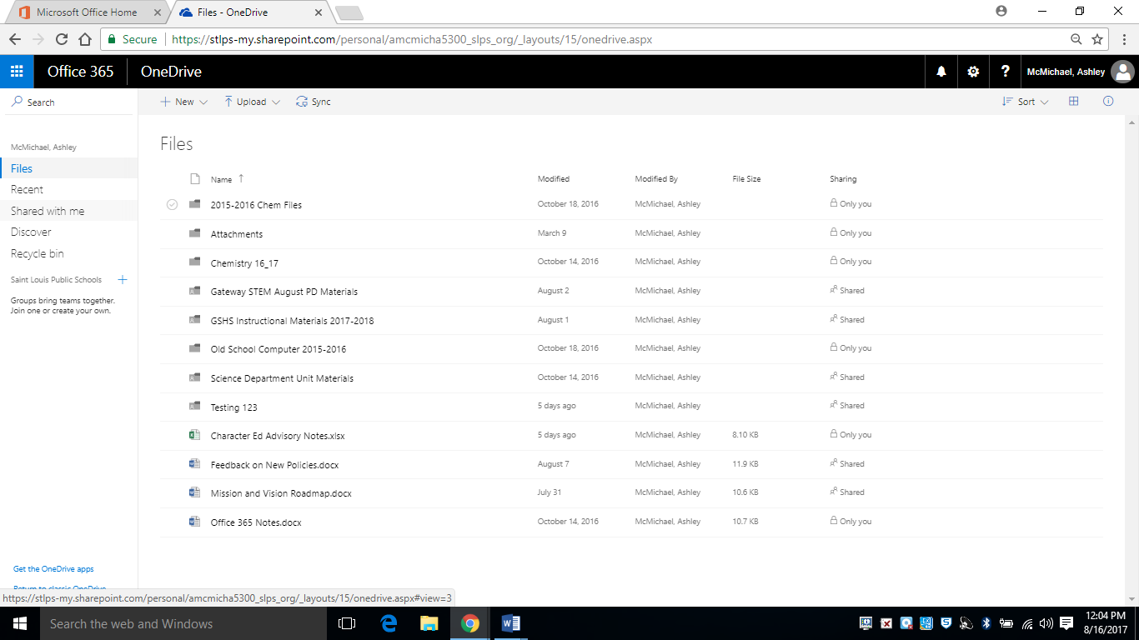

1. Click on GSHS Instructional Materials 2017-2018 (If you cannot see this folder, please email Ashley McMichael)

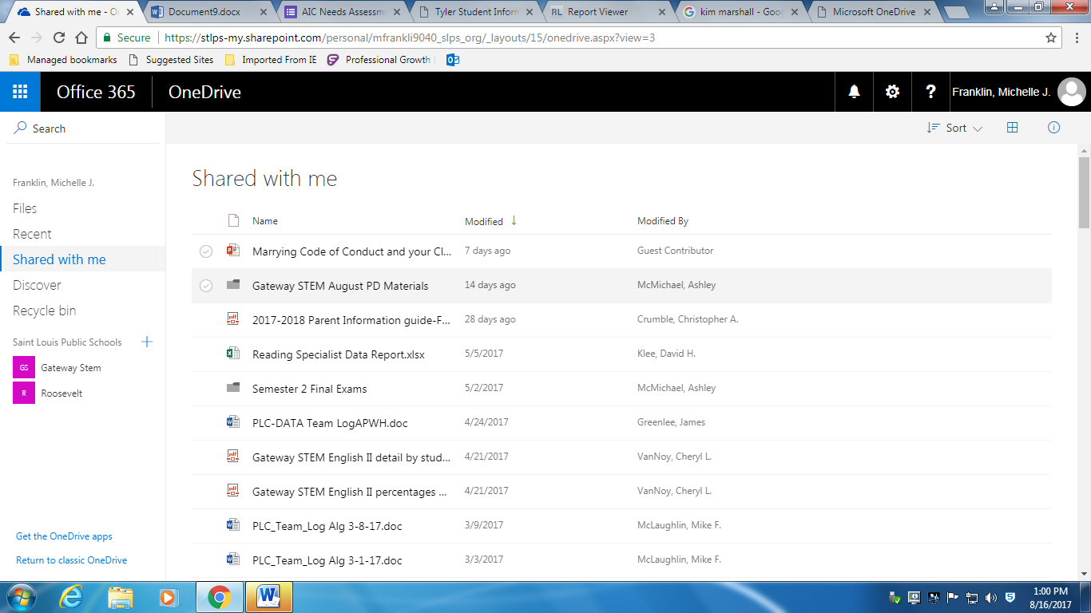

1. Select the Department you belong to (For Example: Business)

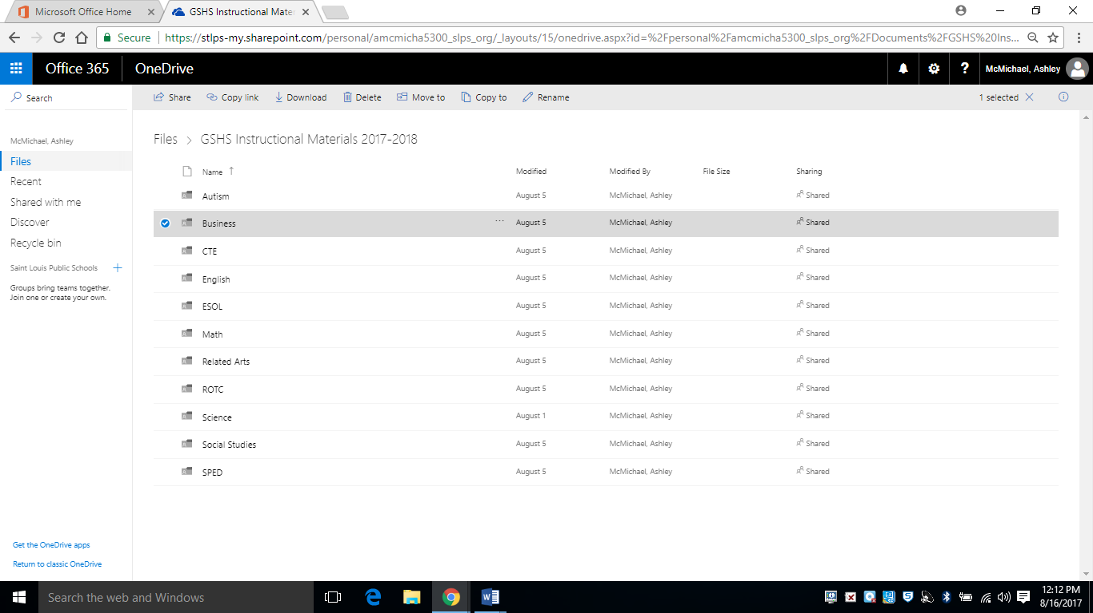

1. Click on Unit Materials

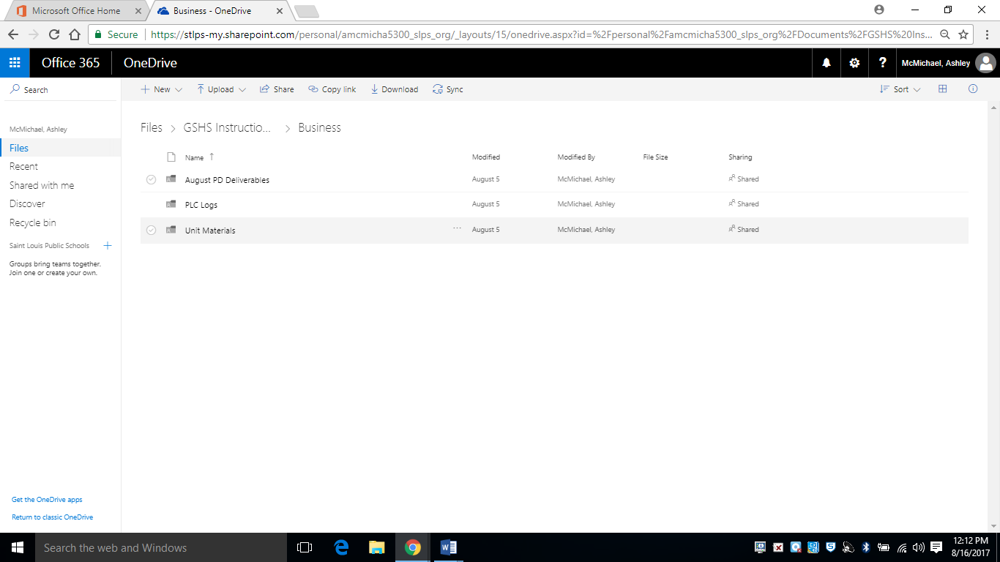

1. Click on the Class you are uploading a syllabus for (If you don’t see your class listed, please contact Ashley McMichael)

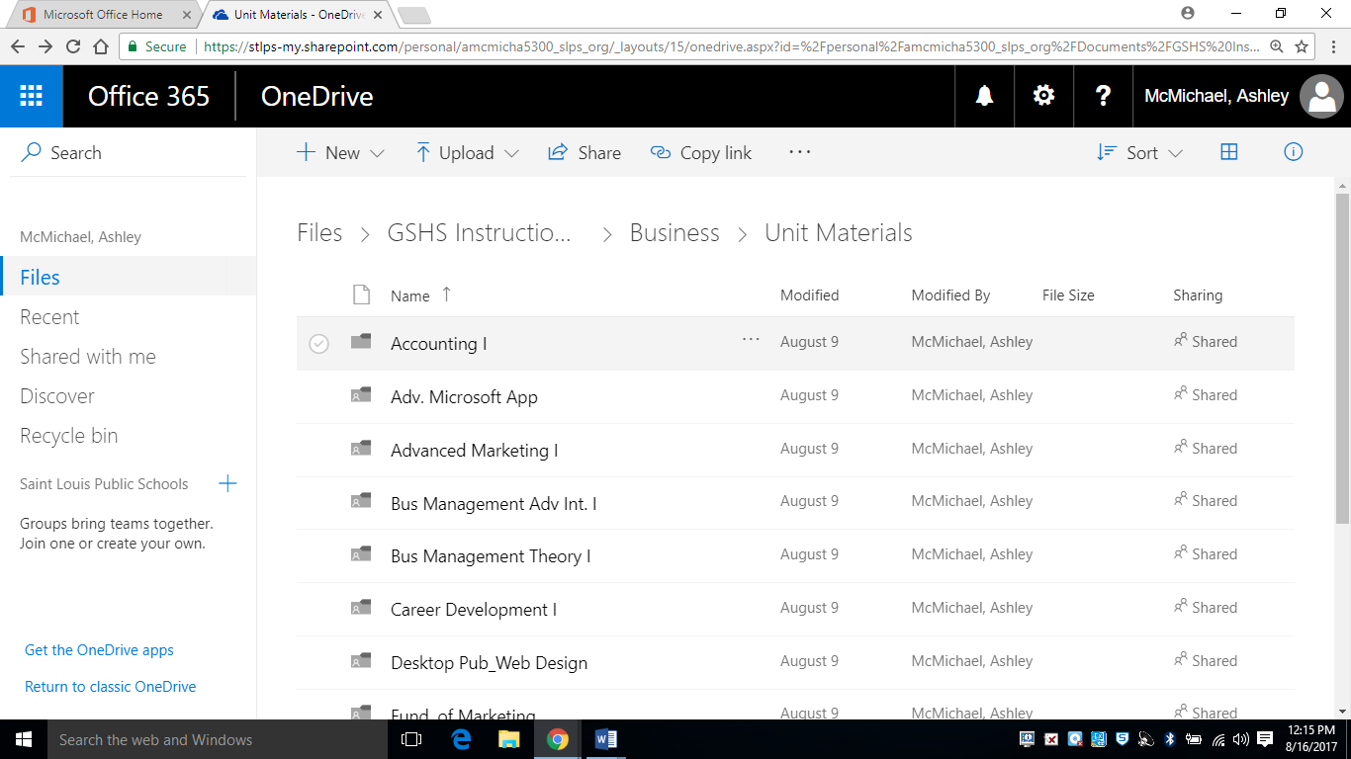

9.) Click on Syllabus

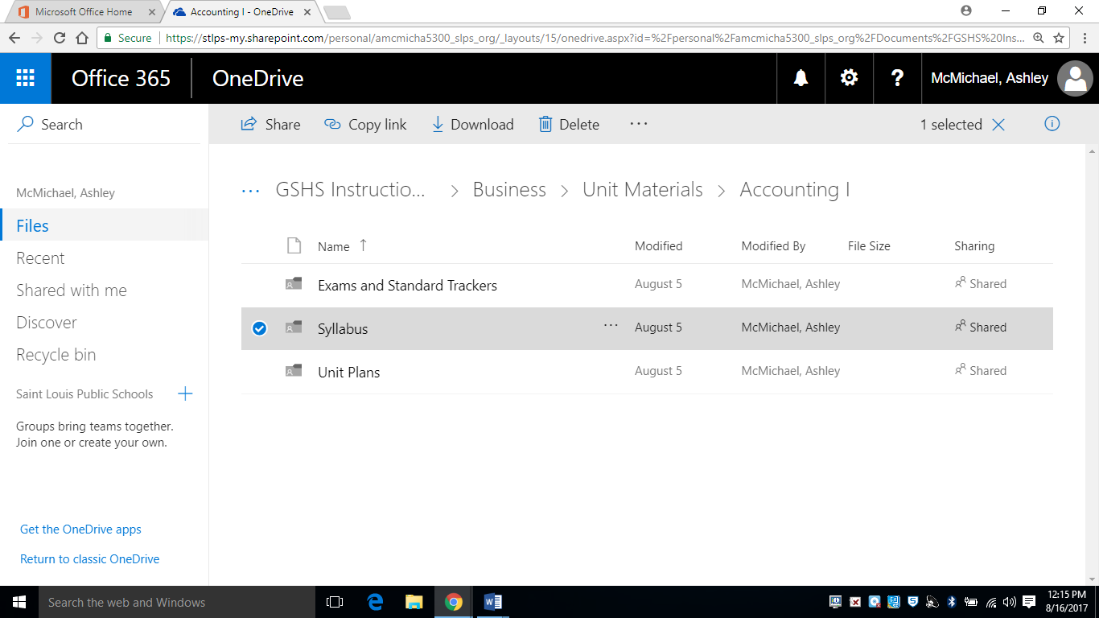

1. Click on Upload, and then select Files.

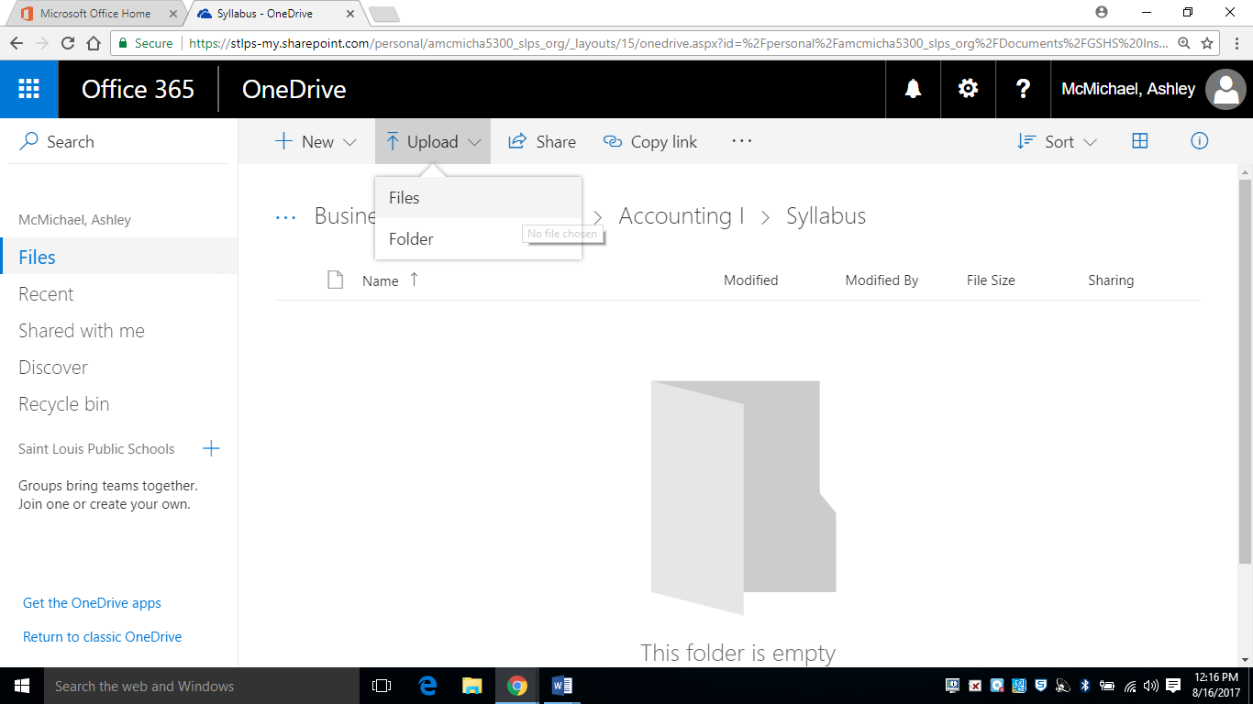

1. From your files, upload your Syllabus for your class.